INSTRUCTIONS FOR AUTHORS

Rules for the design of manuscripts:
1. Manuscripts can be submitted in Kazakh, Russian or English as a file in MS Word (.docx) format.
2. The volume of the manuscript should be 5-10 pages.
3. Font – Times New Roman, size – 12 pt. with a single line spacing. Margins on the left and top – 2.5 cm, on the right and bottom – 2 cm, paragraph – 1.25. The material of the manuscript is drawn up in accordance with GOST 7.5-98 «Magazines, collections, information publications. Publishing design of published materials».
4. In the text, square brackets should be used for references to literary sources – [1], round brackets for formulas – (1). Links to formulas should be located to the right of the formula.
5. All formulas, numerical values, and notation of quantities must be typed in Microsoft Equation 3.0 or MathType format. Each formula should be typed separately if several formulas are in a row.
6. All the symbols used should be explained (it is possible not to explain unambiguous generally accepted designations).
7. You cannot start a sentence with a formula.
8. Tables and illustrations should be arranged as they are mentioned in the text in separate paragraphs. Each table and illustration should have a caption and each table and illustration should have a link in the text. Numbering for tables and illustrations is separate.
9. Illustrations must be of sufficient quality (at least 300 dpi) to clearly identify the content. The illustrations should be numbered. All illustrations and titles of the illustration should be centered, the titles should be centered under the illustration. Illustrations and titles of illustrations should be separated by spaces from the rest of the text. Font – Times New Roman, kegel – 12 pt. After the word «Figure» indicate the serial number and the name of the figure (Figure 1 – The name of the figure).
10. Tables should be created in Microsoft Word table format. All tables should be numbered. The table header should be located to the right above the table. Headings and tables should be separated by spaces from the rest of the text. Font – Times New Roman, kegel – 12 pt. After the word «Table» indicate the serial number and the name of the table (Table 1 – The name of the table).
11. The list of references should be given as cited and include all the works used by the author.
12. Bibliographic lists should be issued in accordance with GOST 7.1-2003 «Bibliographic record. Bibliographic description. General requirements and rules of compilation».

Requirements for the structure of the manuscript:

Structure of the manuscript:
The structure of the manuscript should include the UDC index, the title of the manuscript, information about the authors (full name of the authors, affiliations (names of organizations), name of the country, city, addresses of all authors, e-mail of the corresponding author), annotation, keywords, main provisions, introduction, materials and methods, results and discussions, conclusion, information about financing (if available), list of references, transliterated list of references.
Manuscript design template:

UDC | DOI (issued by a specialist of the Department of Science)

TITLE OF THE manuscript IN ENGLISH

M.G. Shatyrbayeva^{1,*} , M.M. Moldabayeva
(there should be a hyperlink to the Orcid profile in the icon)

¹University (full name), Country, City
²University (full name), Country, City
*e-mail: (e-mail of the correspondent's author)

Abstract (no more than 300 words). The abstract should include the following mandatory items:
Purpose, ideas and main directions of research;
A brief description of the scientific and practical significance of the study;
Brief description of the research methodology;
Main results and analysis, conclusions of the research work;
The value of the conducted research;
Practical significance of the research.
Keywords: 3-10 keywords.

Introduction
The introduction should contain information about the objectives of the work, the importance of the research area, the theoretical and practical significance, the relevance of the problem, the solution of the problem or the formation of a hypothesis.

Materials and methods
This section should consist of a detailed description of materials, equipment and software (including the model, company and country), as well as a detailed description of the methods used, while only new methods should be described in detail; it is sufficient to refer to previously published and well-known methods in the list of references and if the method is not widely known, it is desirable to state its principle and specify the author.
The materials used in the course of the study should be described in qualitative and quantitative terms.
Statistical analysis of the data obtained during the study is mandatory, it is also necessary to specify the software used.

Results and discussions
This section reveals the results of the work and should contain an analysis and discussion of the results of the study. The results should be presented in the form of tables, figures and other illustrative materials with their discussion.

Tables
Tables should be created in Microsoft Word table format. All tables should be numbered. The table header should be located to the left above the table. Headings and tables should be separated by spaces from the rest of the text.

Table 1 – Table name
Title | Result 1 | Result 2 | Result 3
Title 1 | 1 | 2 | 3
Title 2 | 4 | 5 | 6

Illustrations
The illustrations must be of sufficient quality (at least 300 dpi) to clearly identify the content. The illustrations should be numbered. All illustrations and titles of the illustration should be centered, the titles should be centered under the illustration. Illustrations and titles of illustrations should be separated by spaces from the rest of the text.

Figure 1 – The name of the figure

Equations
All equations, numerical values, and notation of quantities must be typed in Microsoft Equation 3.0 or MathType format. Drawings of formulas are not allowed. All formulas must be numbered. Formulas should be centered. The numbering of formulas should be placed to the right of the formula in parentheses. All formulas should be separated by spaces from the rest of the text.

 | $$f=\sum{(a+\frac{a}{10})}$$ | (1)

where: f – designation name;
а – designation name.

Conclusion
This section should summarize and summarize the results of the work carried out, show how the results obtained and their significance for the development of science can potentially be used.

Financing information (if available)
List the sources of funding with the support of which the work was carried out.

List of literature
The list of references should contain at least 10 titles of literature. The list of references should be given as the citation is made and is made in accordance with GOST 7.1-2003. In the text, the reference number should be indicated in square brackets. For example: Korolev's formula [1] proves that (...).

literature:
1.
2.

Transliterated list of references
If there is literature in Cyrillic in the submitted list of references, then it is necessary to submit the list of references in two versions: in the original language in the Literature and in the Romanized alphabet (transliteration into Latin) in References. If there are foreign publications, they are completely repeated in References. Transliteration from Cyrillic can be done using the Online Converter program on the website https://qazlat.kz /.
For transliterated references, the following structure should be used: Author(s) (transliteration) (year in parentheses) The title of the manuscript in transliterated version [translation of the title of the manuscript into English], the name of the source in Cyrillic (transliterated), output data with notation in English.

REFERENCES:
1. Eläsberg P.E. (1965) Vvedenie v teoriu poleta iskustvennyh sputnikov Zemli [Introduction to the theory of flight of artificial Earth satellites], İzdatelstvo "Nauka", 540 p.
2.
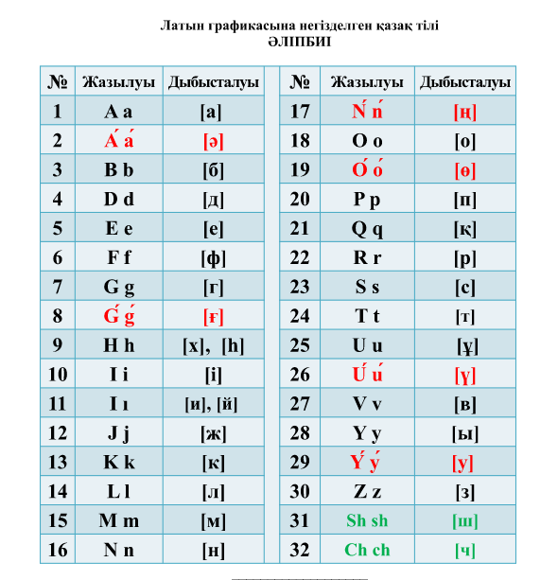

ҚАЗАҚ ТІЛІНДЕГІ ҚОЛЖАЗБА АТАУЫ

Шатырбаева М.Г.^{1,*} , Молдабаева М.М.²

¹Университет (толық атауы), Елі, Қала
²Университет (толық атауы), Елі, Қала
*e-mail: (автор корреспонденттің эл.почтасы)

Аннотация (300 сөзден аспауы тиіс). Аннотация келесі міндетті тармақтарды қамтуы керек:
Зерттеудің мақсаты, идеялары және негізгі бағыттары;
Зерттеудің ғылыми және практикалық маңыздылығының қысқаша сипаттамасы;
Зерттеу әдістемесінің қысқаша сипаттамасы;
Зерттеу жұмысының негізгі нәтижелері мен талдаулары, қорытындылары;
Жүргізілген зерттеудің мәні;
Зерттеудің практикалық маңызы.
Кілт сөздер: 3-10 кілт-сөздер.

НАЗВАНИЕ РУКОПИСИ НА РУССКОМ ЯЗЫКЕ

Шатырбаева М.Г.^{1,*} , Молдабаева М.М.²

¹Университет (полное название), Страна, Город
²Университет (полное название), Страна, Город
*e-mail: (эл.почта автора корреспондента)

Аннотация (не более 300 слов). Аннотация должна включать следующие обязательные пункты:
Цель, идеи и основные направления исследования;
Краткое описание научной и практической значимости исследования;
Краткое описание методологии исследования;
Основные результаты и анализ, выводы исследовательской работы;
Ценность проведенного исследования;
Практическое значение исследования.
Ключевые слова: 3-10 ключевых слов.

Appendix B

Авторлар туралы мәлімет

Т.А.Ә. | Паспорт/жеке куәлік бойынша
Ғылыми атағы, ғылыми дәрежесі
Қызметі немесе мамандығы
Жұмыс орны (ұйымның толық атауы, қала)
Мемлекет (шет елдік авторлар үшін)
e-mail

Сведения об авторах

Ф.И.О. | По паспорту/удостоверению
Ученое звание, ученая степень
Должность или профессия
Место работы (полное название организации, город)
Страна (для иностранных авторов)
e-mail

Information about authors

Full name | Passport / ID
Academic degree, academic title
Position or profession
Place of work (full name of the organization, city)
Country (for foreign authors)
e-mail

